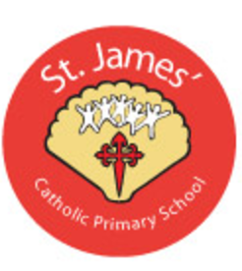
ST. JAMES’ CATHOLIC PRIMARY SCHOOL
Where we belong, believe and achieve’

Head Teacher: Mrs. A. J. Blacoe
Ashurst Road, Ashurst, Skelmersdale. WN8 6TN Email: bursar@st-james-pri.lancs.sch.uk
T: 01695 728989 head@st-james-pri.lancs.sch.uk

Website: www.st-james-pri.lancs.sch.uk

Dear Parents / Carers,

At St James’ we regard the safeguarding of the children to be of paramount importance. In the event of your child not being collected by the usual Parent/Carer, we require that anyone collecting your child know a unique password that they can give to a member of staff at the classroom door.

We advise that the password be unique and easy to remember for example the name of a pet or your child’s favourite toy.

Each password will be kept within the Foundation Stage.

Please can you complete the form below and return it to school with your application forms.

Thank You

Foundation Stage Password

Parent/Carer Name: ______________________________________________________________________

Child’s Name: ____________________________________________________________________________

Unique Password: ________________________________________________________________________

Signed: ________________________________________________________Dated: ___________________

