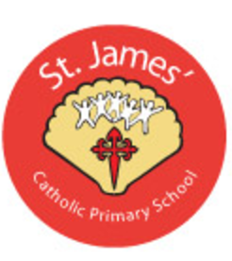
ST. JAMES’ CATHOLIC PRIMARY SCHOOL
We belong to the loving family of St. James’

Head Teacher: Mrs. A. J. Blacoe
Ashurst Road, Ashurst, Skelmersdale. WN8 6TN Email: bursar@st-james-pri.lancs.sch.uk
T: 01695 728989 head@st-james-pri.lancs.sch.uk

Website: www.st-james-pri.lancs.sch.uk

Permission Form for the Provision of Care

At St James’, it is our policy that if a child wets or soils themselves while they are at school it is important that measures are taken to have them changed (and if necessary cleaned) as quickly as possible. Our staff, particularly in the Foundation Stage are experienced at carrying out this task. St James’ Catholic Primary School has an Intimate Care Policy which is available to view on our website, or ask for a copy from the office.

Yours sincerely

Mrs A J Blacoe
Head Teacher

Name of child:…………………………………………………………………………

I give permission for my child to have their nappy changed whilst at Nursery.

I give permission for them to be lifted and placed on to the changing mat.

I give permission for staff to apply nappy cream which has been provided from and will discuss this with a member of staff.

Signature of parent ………………………………………………………… Date……………………

If your child suffers from an attack of diarrhoea, it is the policy for St James’ Catholic Primary School not to accept them back to school for 48 hours after the symptoms have cleared.

