St James’ Media Club presents:
St James’ leavers 24
 | 30/11/2023 | Written by Max, Joe, Faith, Gracie, Ben, Oscar, Hattie & Isla
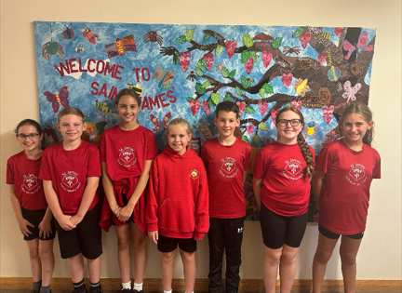
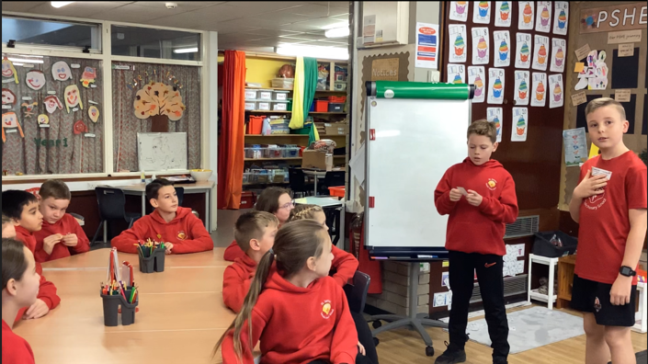
What’s new this term with pupil parliament?
Faith [Wellbeing]: Make sure people are feeling happy and if not take them to the wellbeing teacher Mrs Allan.
Max: Freya your role is Live Simply. What can you do to make our school live simply?
Freya [live simply]: Make paper, plastic and cardboard bins.
Ben: Use the litter pickers more often.
Max: Hannah your job is fundraising. How can you do that?
Hannah [fundraising]: I would probably do some sponsored runs.
Max: Anything that anyone else could do to help the school?
Ben: Maybe something about football.
Oscar: An all-weather pitch that all the years can share.
Joe: One with like a tarp over it.

And that was the whole interview between Media club and Pupil Parliament. Let’s hope that if our pupil parliament work hard enough, we can get all of these things!

We have recently interviewed our pupil parliament which consists of pupils in year 3-6 Here’s what was discussed:

Max [media club]: What are your hopes to help improve our school?
Hattie [prime minister]: Try our best and help get equipment in class.
Joe [media club]: Is there anything anyone would like to add onto that?
Ben [pupil parliament]: Like equipment for all classes
Max: Like what?
Ben: Sports equipment and other things to help learning in class.
Hattie: More maths equipment and stationery.
Max: Does anyone have any ideas to add on to our children’s learning?
Hattie: We need to make sure that they have the right equipment for their learning.
Max: Faith your job is wellbeing what would you do about that?

DO YOU FEEL DOWN?
St James’ can help!
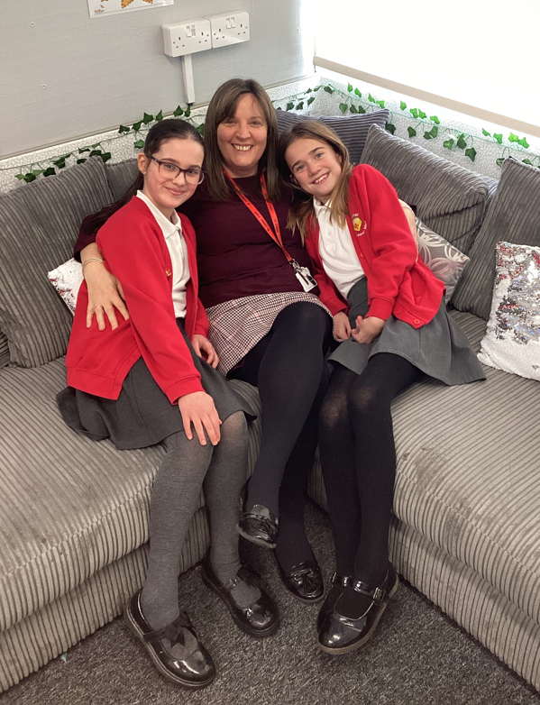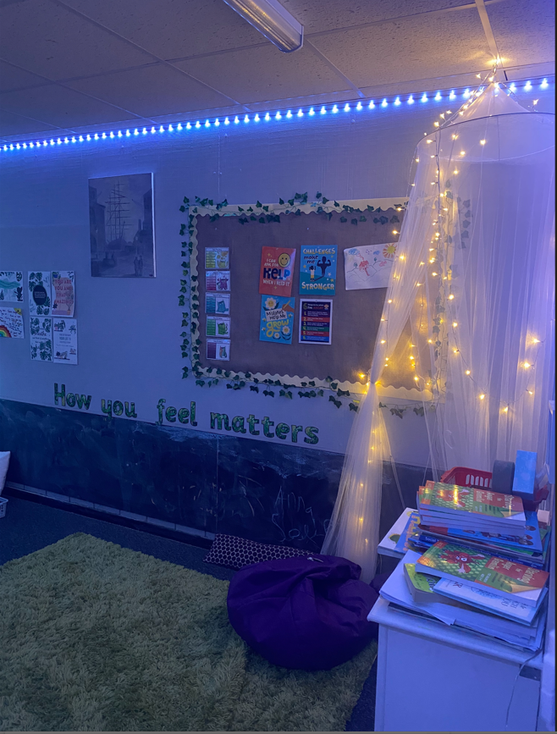
Picture: This is Mrs Allan, Faith and Gracie & our school Nurture Room
The latest breaking news
Well lets turn that frown upside down!
faith and gracie

If you ever feel annoyed or upset you can come to any teacher and speak to them about what has happened. Your specialist for problems is Mrs Allan. | Don’t let anybody control you about, if you don’t want to and if they say well “I wont be your friend” then they are not being very kind. Make sure to stay safe and if you play out make sure to go out with someone you trust like your best friend and don’t follow anyone who tells you to.

Mrs Allan will look after you and care for you and she can also take you to a special place named The Nurture Room where you can let out all of your problems and emotions.You can speak to pupil parliament if you want to too. Im Faith and I’m in pupil parliament. My important role is in Wellbeing and if you want to speak to me you can! Mrs Allan will help you with anything such as an arguments, being left out, missing anyone/anything and loads more. Mrs Allan doesn’t mind you expressing your feelings and emotions. | Feel safe to talk to someone with your worries. There is always someone who will listen and help you in St James’. |  | You can always speak to a friend that you can trust. But be sure to be careful who you speak to because it could be very important. You can trust any pupil parliament and media club because you can trust us and talk to us about anything that makes you angry or sad.  If your outside of school and you think someone is chasing/following you that you don’t know run somewhere safe and go to an adult. If someone is telling you to do something that you don’t want to do or that isn’t comfortable don’t be afraid to say NO!!
Do you need some ways to calm yourself? Are you feeling sad, mad or scared? Is someone being mean to you or shouting at you?  If you need any of these questions answering, speak to Mrs Allan. |  | Do you feel alone? Do you feel stressed? Do you need to talk to someone about how your feeling?  Mrs Allan is here to help you with all your worries and problems.
Page 2

Tuesday, September 1 2023 | The events this term |  |  | From September to December
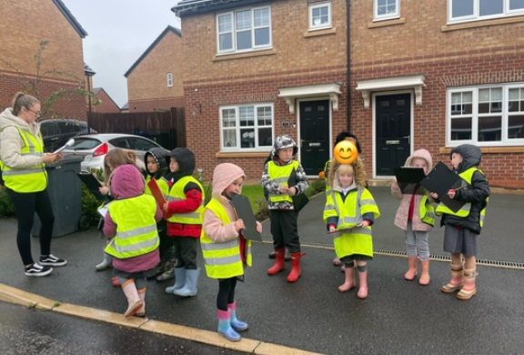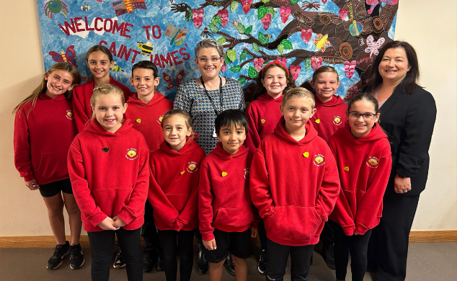
Latest events this term. Written by Isla and Hattie

media club.
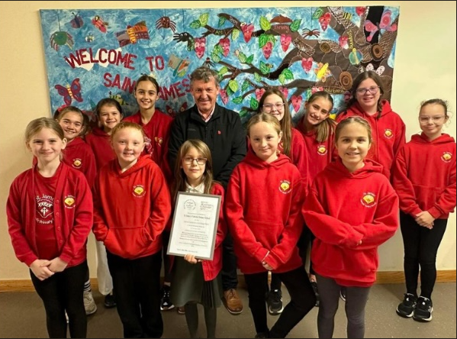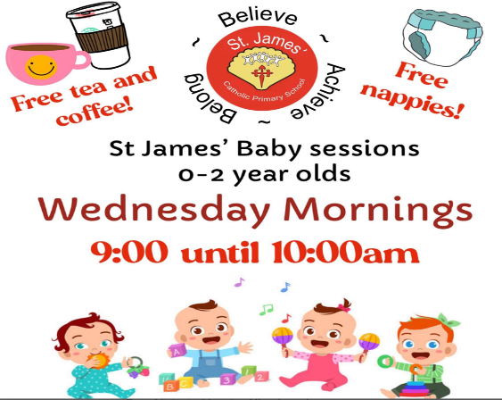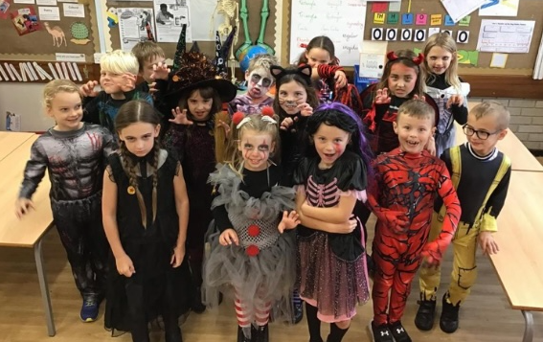
 |  |  | At St James’ there are lots of opportunities for sport things like football, netball, dodgeball and benchball. All these sports we play in competitions but theres LOTS more that we do in P.E. This half term we are doing gymnastic’s.
pupil parliament  And the prime minister Hattie curry  There are some events that include Pupil Parliament and the Prime Minister. For example Hattie and Freya went to a SHARES meeting because they are looking for pupil parliament and a prime minister for Skelmersdale. They had to create a speech over the weekend and present it to a big crowd. They waited to find out who it was and… Hattie has got the role of secretary of SHARES for pupil parliament for Skelmersdale. The two girls were great! Freya was an excellent role model and she should be very proud of her self |  | 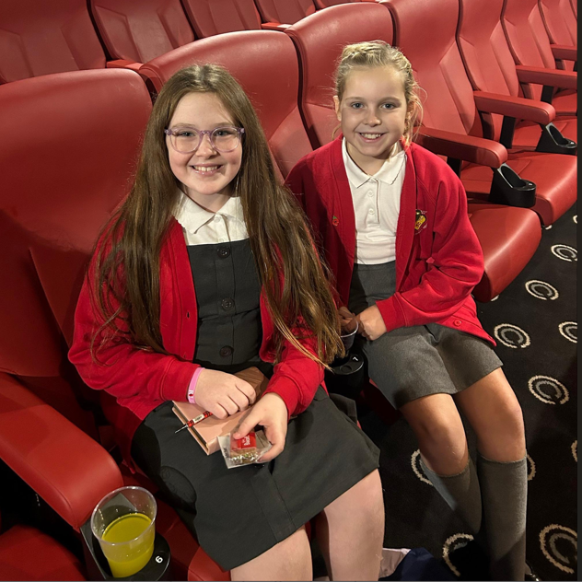  Picture: Hattie and Freya at the SHARES meeting. | school trips  for every class  Now we’re going to mention some trips that has been or what’s coming up first.  RECEPTION:fieldtrip-11th october 2023  YEAR 5:formby beach-2nd november 2023  YEAR 2-fieldtrip 19th october 2023  YEAR 4- school trip to the beacon  RECEPTION -post letters to santa 29th November  YEAR 4-river tawd field trip 13th march 2024  RECEPTION-bring your wellies 27th march 2024  YEAR 4-hothersall lodge 1 night stay 2nd may 2024  YEAR 5-london trip 28th june 2024  YEAR 6-robinwood -2 nights 15th july 2024  ff
Now we are going to tell you some of the dates for  important stuff  Hope you enjoyed |  | Y4 timestable check-10th june  Y1 Phonic screening-10th june-14th june  And there are the year 6 SATS  NATIVITY-Y1+Y2-Prickly hay  KS2 CAROL CONCERT-6pm at church 14th december 2023  Brekfast with Santa,Santa dash and raffle-21st december 2023  Whole school fundraiser Y6-9th Febuary  World book day – 7th march  Mothers day asembley-RECEPTION-8th March | JIMMY’S BONGO’S BINGO-Y1 up in till Y6-7th march  EASTER BONET+Parade- 28th March  PARTY-PICNIC THE PARK-familys can join+classes to perform-17th May  MACMILLAN CANCER SUPPORT-Friday 13th October  FIRST COMMUNION MASS+Celebration Y4-Y5- 21st June  Y6 PANTOMINE STUDENTS-1:30PM (8TH JULY)  PARENTS 7pm (9th JULY)  RECEPTION GRADUATION-9AM-10th JULY  ICE CREAM PARTY (whole school)-17th July  LEAVERS ASSEMBLY Y6-19th JULY
Page 3
Fancy a laugh?
By Bonnie, Keithy & Jennifer

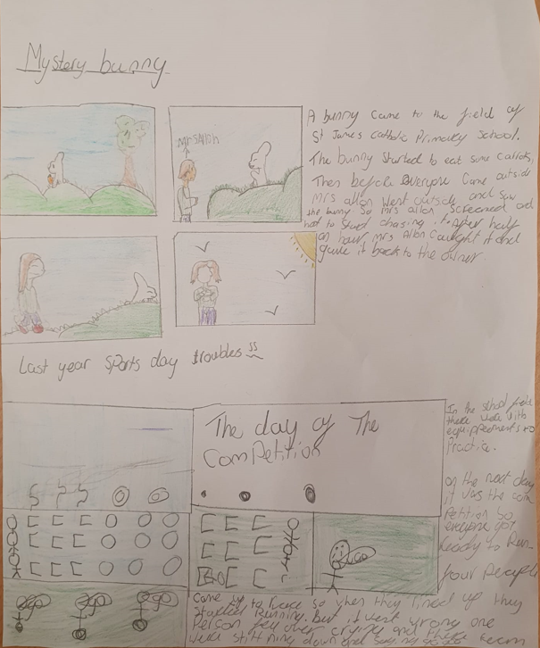

From September 2023 to December 2023  Tuesday 14 November | Sports Events at St James’
Super Sports
Want To Know What Is Going On in the Sports In School?
BEN HOLDEN AND OSCAR BODELL

The first boys Y5, Y6 tournament including the players are:
Oscar, CB
Oscar, CM
Max, Captain, CM
Caleb, RW
Tom, GK
Max, ST
Joe, CB
Joe, CB
Ben, LW

The boys team scores were:

8-0, 4-0, 0-0, 3-0, 0-0, 6-0, 3-2, 3-0, 4-0

The girls Y5, Y6 touranment including the players are:
Hattie, ST
Heidi, MID
Freya, DF
Isla, MID
Ayla, MID
Soren, DF
Drew, DF
Ruby, GK
The girls scores were:
2-0, 6-0, 3-0, 3-0, 3-0, 3-0, 1-0, 0-0

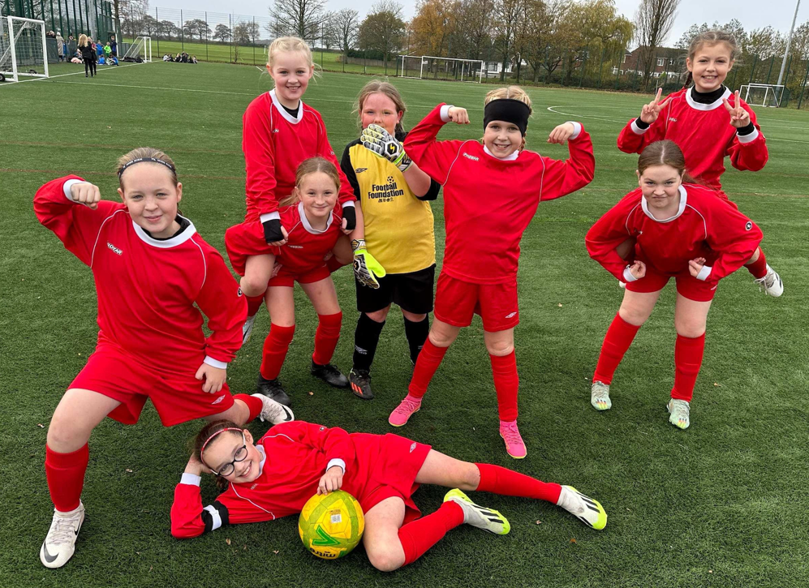
Trophy Cabinet displayed at St James’ Catholic Primary School.

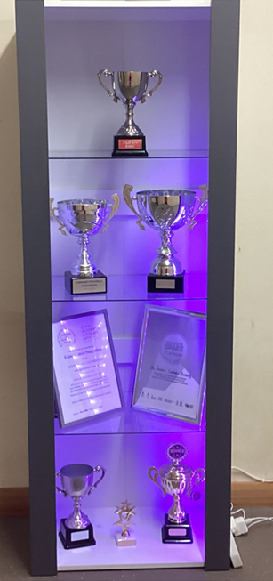
What’s Happening?

The school football team has done so well to come 1st in THE WHOLE OF SKELMERSDALE AND DIDN’T LOSE A MATCH!!! There is now a trophy cabinet on the way into school with a number of trophies all ready displayed with more to come.

The girls have just finished their tournament and came 1st in the whole of West Lancashire
out of twenty different teams and conceded
absolutely no goals!

lll
Sports clubs this Term:

The school clubs this half term have been:
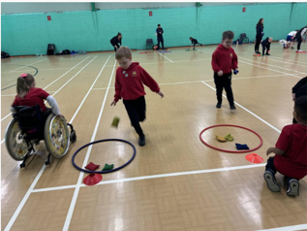
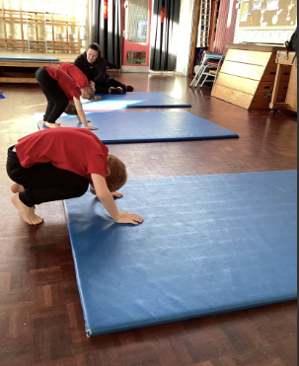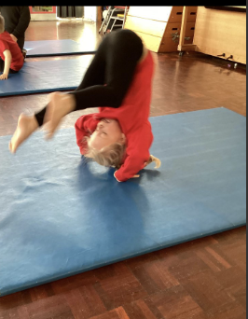
Bench Ball for Year 3 and 4 at Upholland.
Dodgeball club for Year 5 and Year 6 at Upholland and OLQP.
Football club for Year 5 and Year 6
Gymnastics club for KS1 & KS2
OAA for Year 3 & 4
Dance for KS2
Bikability for Y5.
Sports Councillors for Y5
Platinum Award

Our trophy cabinet showcases all of our after school achievements too!!

